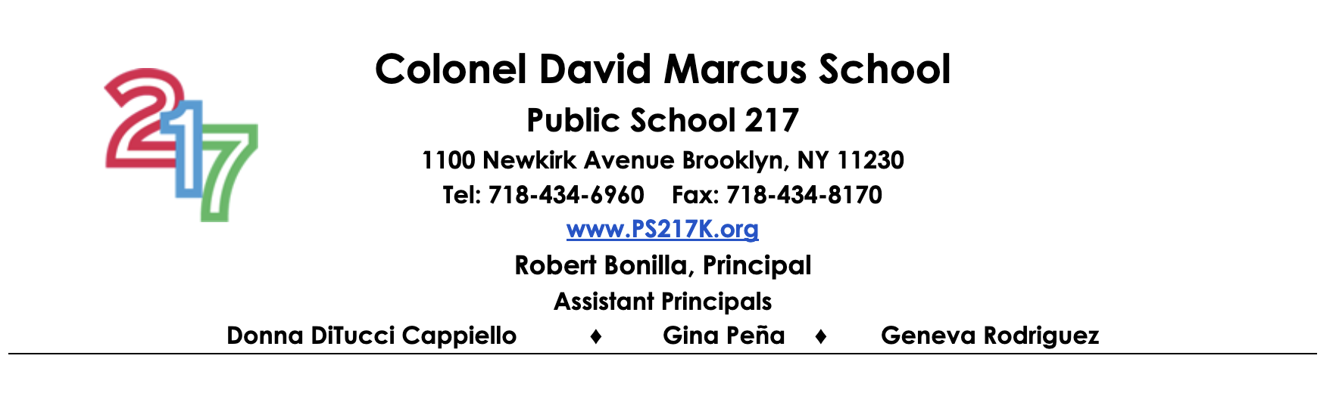

September 5, 2024

Dear 217 Families,

Welcome to the 2024-2025 school year! We could not ask for better weather or community to kick this year off. The first day of school is my all-time favorite day of the year. It’s a time for fresh starts and new beginnings. Once again, we will have numerous times for you to be engaged in your child’s learning. From First and Second Fridays to our legendary festivals, we cannot wait to see you and officially welcome you back into the building.

Your child’s teacher will be introducing a wonderful home project to jump start the year. This project will allow our teachers an opportunity to not only learn more about your child but you as well. My wish for us this year is to stay healthy, safe and engaged in the learning process. We are here for your children and will do whatever it takes to ensure a HAPPY school year filled with joy!

Respectfully,

Robert E. Bonilla