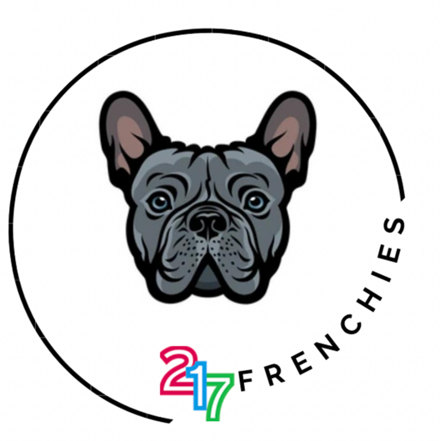

No Discovery Zone
&
ENL Lexia Program


Tuesday, December 23rd

